**Appendix A**

**Visual Discrimination Task**

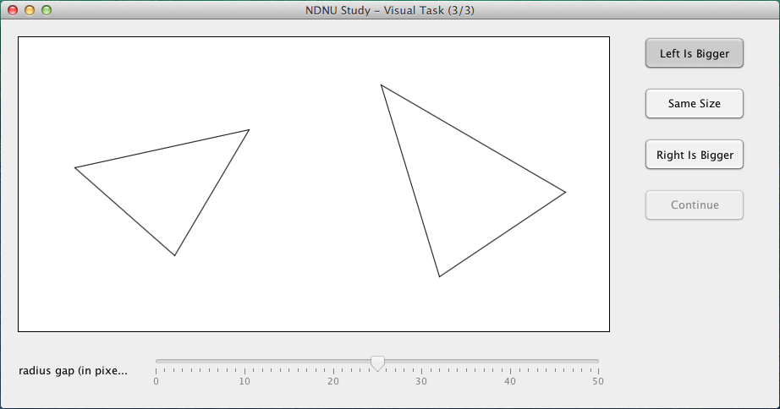

**Appendix B**

**Verbal Discrimination Task**

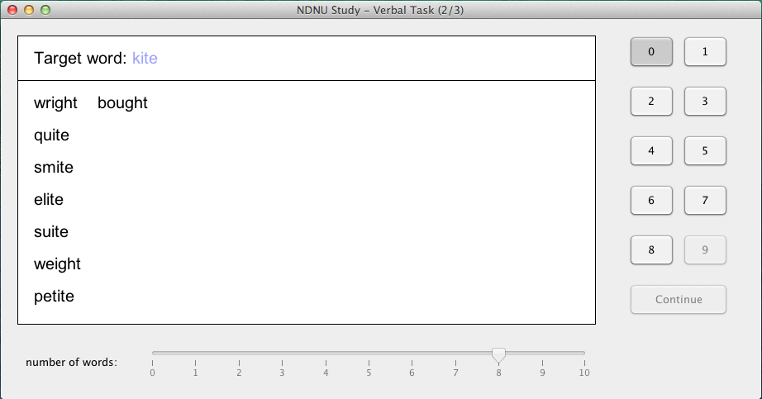

**Appendix C**

**Kinesthetic Action Task**

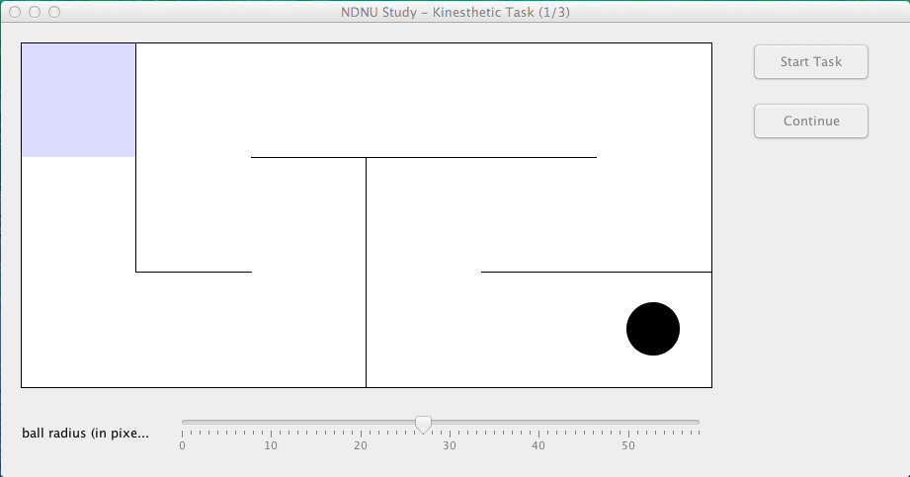

**Appendix D**

**Recruitment Flyer**

Seeking adult participants to play video games for a study

No gaming experience necessary

Research is focused on finding the best difficulty level of three different types of games

Participants may be of any gender or race and of

any level of gaming experience

Participants must be 18 years of age or older to participate

Completion of the study involves playing games for 15 to 20 minutes and can be completed at any internet-capable computer with a mouse

To take part in this study, please visit www.NDNUvideogamestudy.com

**Appendix E**

**Informed Consent Statement**

Notre Dame de Namur Informed Consent Statement

## Preferred Difficulty Levels in Novel Computer-Based Tasks

You are invited to participate in a research study, the purpose of which is to help understand the factors contributing to preferred difficulty levels in novel computer-based tasks.

**INFORMATION**

To help us in this task, we will ask you to participate in a study which lasts approximately fifteen (15) to twenty (20) minutes. You will be asked to complete different types of tasks and to adjust the difficulty level of those tasks to be the most enjoyable for you. There will be three different types of tasks: visual, verbal, and kinesthetic.

For the visual task, you will be asked to picture a circle which goes through all three vertices of a triangle. You will be asked to compare the sizes of two of these circles.

For the verbal task, you will be asked to decide how many words in a list rhyme with a target word. You will have three (3) seconds to complete this task. For instance, if the target word is "our", and the list contains "power", "pour", "grower" and "sour", you would answer by pressing '2' (since "power" and "sour" rhyme with "our", but "pour" and "grower" do not).

For the kinesthetic task, you will be asked to navigate a ball through a maze. If the ball touches the wall, you start from the beginning again.

For each of these types of tasks, the difficulty level can vary between trials for up to the first fifteen (15) trials. You will then be asked to set the difficulty level to a constant value for the next up to fifteen (15) trials. Please choose carefully when doing so, as once you make your choice this value cannot be altered for the following trials.

A target of 100 participants has been set for this trial.

**RISKS**

There are no foreseeable risks associated with this study.

**BENEFITS**

The results of this study will help benefit scientific understanding of what people want to experience when interacting with computer-based tasks. Such information will be beneficial to the design of both educational and recreational video games.

**CONFIDENTIALITY**

The data obtained in this study will be treated as confidential and will be stored securely on a server. You will not be asked to contribute any identifying information. Your responses will be encrypted before being sent to the server, and no personal information about you or your computer will be sent with your responses. The program with which you are interacting will not place any cookies on your computer and will not transmit data about the session to any third parties. Data from your responses will be saved for at least three (3) years after completion of the study. Data will be destroyed no more than ten (10) years after completion of the study.

**COMPENSATION**

You will receive no monetary compensation for participating in this study.

**CONTACT**

If you have any questions at any time about the study or its procedures, you may contact the principal investigator, Steven Riley, at 619-757-8799 or at NDNUVideoGameStudy@gmail.com. If you feel you have not be treated according to the descriptions in this form, or your rights as a participant have been violated during the course of this study, you may contact the Research Integrity Officer (RIO) at the office of the Provost at NDNU by calling (650) 508-3494.

**PARTICIPATION**

Your participation in this study is voluntary. You may decline to participate and have your data withdrawn at any time before, during or after completing the tasks in this program. If you decide to participate, you may discontinue participation at any time without penalty or loss of benefits to which you are otherwise entitled.

**CONSENT**

If you are not eighteen (18) years of age or above, you are not able to give consent to complete this study. By clicking "I agree", you state that you have read this consent form and that you understand the above information. Please save a copy of this page for your records.

**Appendix F**

## Debriefing Statement

Thank you for your participation in this research on the preferred difficulty level of computer based tasks. Novel computer-based tasks were used for all participants in this study. The goal of the study was two-fold: to gather information on computer-user's preferred task difficulty, and to attempt to validate an algorithm which predicts outcome percentage. It was hypothesized that participants would all prefer approximately the same percentage of correct trials for a task, and that each would set difficulty levels in such a way as to achieve this percentage correct.

Current research has found that participants prefer a moderate level of difficulty for tasks. Your participation was important in helping researchers find that level of difficulty and predict the optimal level for future tasks.

Final results will be available from the investigator, Steven Riley, by 2/13/2015. You may contact me at NDNUVideoGameStudy@gmail.com to receive an email copy of the final report. All results will be grouped together; therefore individual results are not available. Your participation, including your name and answers, will remain absolutely confidential, even if the report is published. If you have any additional questions regarding this research, please contact me at NDNUVideoGameStudy@gmail.com.

**Appendix G**

**Big Five Personality Inventory**

**Retrieved from** [**http://www.ocf.berkeley.edu/~johnlab/pdfs/BFI.doc**](http://www.ocf.berkeley.edu/~johnlab/pdfs/BFI.doc)

**Bold items comprise the neuroticism scale**

**Non-bold items will not be used in the study**

**How I am in general**

Here are a number of characteristics that may or may not apply to you. For example, do you agree that you are someone who *likes to spend time with others*? Please write a number next to each statement to indicate the extent to which **you agree or disagree with that statement.**

|  |  |  |  |  |
| --- | --- | --- | --- | --- |
| **1**  Disagree  Strongly | **2**  Disagree  a little | **3**  Neither agree  nor disagree | **4**  Agree  a little | **5**  Agree  strongly |

**I am someone who…**

1. _____ Is talkative
2. _____ Tends to find fault with others
3. _____ Does a thorough job
4. **_____ Is depressed, blue**
5. _____ Is original, comes up with new ideas
6. _____ Is reserved
7. _____ Is helpful and unselfish with others
8. _____ Can be somewhat careless
9. **_____ Is relaxed, handles stress well.**
10. _____ Is curious about many different things
11. _____ Is full of energy
12. _____ Starts quarrels with others
13. _____ Is a reliable worker
14. **_____ Can be tense**
15. _____ Is ingenious, a deep thinker
16. _____ Generates a lot of enthusiasm
17. _____ Has a forgiving nature
18. _____ Tends to be disorganized
19. **_____ Worries a lot**
20. _____ Has an active imagination
21. _____ Tends to be quiet
22. _____ Is generally trusting
23. _____ Tends to be lazy
24. **_____ Is emotionally stable, not easily upset**
25. _____ Is inventive
26. _____ Has an assertive personality
27. _____ Can be cold and aloof
28. _____ Perseveres until the task is finished
29. **_____ Can be moody**
30. _____ Values artistic, aesthetic experiences
31. _____ Is sometimes shy, inhibited
32. _____ Is considerate and kind to almost everyone
33. _____ Does things efficiently
34. **_____ Remains calm in tense situations**
35. _____ Prefers work that is routine
36. _____ Is outgoing, sociable
37. _____ Is sometimes rude to others
38. _____ Makes plans and follows through with them
39. **_____ Gets nervous easily**
40. _____ Likes to reflect, play with ideas
41. _____ Has few artistic interests
42. _____ Likes to cooperate with others
43. _____ Is easily distracted
44. _____ Is sophisticated in art, music, or literature

**SCORING INSTRUCTIONS**

To score the BFI, you’ll first need to **reverse-score** all negatively-keyed items:

Extraversion: 6, 21, 31

Agreeableness: 2, 12, 27, 37

Conscientiousness: 8, 18, 23, 43

Neuroticism: 9, 24, 34

Openness: 35, 41

To recode these items, you should subtract your score for all reverse-scored items from 6. For example, if you gave yourself a 5, compute 6 minus 5 and your recoded score is 1. That is, a score of 1 becomes 5, 2 becomes 4, 3 remains 3, 4 becomes 2, and 5 becomes 1.

Next, you will create scale scores by ***averaging*** the following items for each B5 domain (where R indicates using the reverse-scored item).

Extraversion: 1, 6R 11, 16, 21R, 26, 31R, 36

Agreeableness: 2R, 7, 12R, 17, 22, 27R, 32, 37R, 42

Conscientiousness: 3, 8R, 13, 18R, 23R, 28, 33, 38, 43R

Neuroticism: 4, 9R, 14, 19, 24R, 29, 34R, 39

Openness: 5, 10, 15, 20, 25, 30, 35R, 40, 41R, 44

**Appendix H**

**Recruitment website screenshot**

